

Course Name: Introduction to Software Engineering
Course Code: IS1103-1
Assignment Number: 1
Title: Study of Software Development Life Cycle Models with Reference to Amazon
Student Name: Anna Seric Fernandes
USN / Roll Number: NNM24IS033
Semester: IV
Section: A
Department: Information Science & Engineering
Institution Name: NMAM Institute of Technology
Academic Year: 2025-2026
Instructor Name: Dr. Jason Elroy Martis
Date of Submission: 15-02-2026

ABSTRACT
This report is about the Software Development Life Cycle of the Amazon Online Shopping Application. A lot of people use the Amazon Online Shopping Application every day. The Amazon Online Shopping Application is used by a number of people, around the world.

It is really hard to manage the things the Amazon Online Shopping Application needs to do because it has to change quickly and handle a lot of people using it on the internet at the same time and it has to be safe and work well.

We will look at three Software Development Life Cycle models the Software Development Life Cycle models are the Waterfall model, the Incremental Development model and the Spiral model to see how they work for the Amazon Online Shopping Application. The main thing we want to do is figure out how each model helps with managing requirements controlling risks and keeping track of cost and time. We need to understand how each model supports requirements managing and how it helps with risk control and how it affects cost and time.

Basic features like product search ordering, payments and user accounts are a part of the requirement documents. It seems necessary to have qualities, like security, efficiency and being easily usable and to take care of many user needs. The report discusses how the requirements are tested through discussions, simple prototypes and reviews. Changing product requirements and communication problems are problems that are talked about in the report and these problems are related to product requirements and user accounts.

After looking at all the models we decided that Incremental and Spiral models are the best for a changing system like Amazon. The Waterfall model does not handle risks and updates easily as the Incremental and Spiral models. This tells us that for ecommerce applications like Amazon it is really important to develop things step, by step and manage risks properly. We think that Incremental and Spiral models are better because they help us deal with changes and risks in a way. For ecommerce apps Incremental and Spiral models are the way to go because they make it easier to update and change things as we go along.

GITHUB REPOSITORY LINK
https://github.com/annaprint28/ISE-Task-1-SDLC-/tree/report

INTRODUCTION
This project is about Amazon Online Shopping App development. It shows us how the Software Development Life Cycle is helpful.The Software Development Life Cycle is really useful when it comes to Amazon Online Shopping App development.We need to understand how to manage the requirements of an complicated system like Amazon Online Shopping App.To do this we have to look at the differences between the Waterfall model, the model and the Spiral model of the Software Development Life Cycle.Looking at these models the Waterfall, Incremental and Spiral models, is very important to understand the management of requirements, in Amazon Online Shopping App development.
We make sure to explain how the requirements are approved. We also make a simple document for the requirements.When we build a system that is updated often there are things we need to think about, like how well the system works and what could go wrong.We compare models to identify what we need.
The requirements are very important. We need to get them right.
Deep learning is also very important for making recommendations getting good search results detecting fraud and making sure the customer is happy.
This is connected to Unit I, where we learned about the models, for building software how to figure out what the requirements are and how to make sure everything works correctly.
We need to understand the requirements and the system to make it work well. That is why the requirements are so important.

PROBLEM STATEMENT
This case study is about figuring out how a huge application like Amazon can be created using software development methods such as the Waterfall model, the Incremental model and the Spiral model. Amazon is an app and it is interesting to see how Amazon can be built using these different software development life cycle models, like the Waterfall model, the Incremental model and the Spiral model.
In this way we are trying to figure out how each model takes care of requirements in a huge and complex system.People need some things from a website. They want to be able to search for products place orders and make payments. They also want to know that the website is secure works well and is reliable. These are the things that a website should have and they are written down in a requirements document, for the website. The website needs to have security, good performance and good reliability just like people need these things when they use a website to search for products place orders and make payments.The goal is to find out which model is best for an app like Amazon. Amazon is always. Changing. We need to figure out which model is the fit for Amazon. The model has to be good for an app, like Amazon that is always getting bigger and doing things.

We look at how each model handles risks and also how it deals with changing requirements and how it affects time and cost. Each model manages risks in its way and we compare how they do it and how they change when requirements change and how that impacts the time it takes and the cost of each model.
We do not have permission to access Amazons internal data so we have to use what we know about e-commerce apps and the basics of software engineering concepts. We are talking about Amazon. We have to rely on general information, about Amazon and other e-commerce apps.We make some things simple because we do not have a lot of time and resources to work with [1].

SYSTEM DESCRIPTION
The Amazon app is really big. A lot of people use it to shop online every day. It deals with much information so quickly. People use the Amazon app to buy things sellers use the Amazon app to sell things. The Amazon app helps people pay for these things at the same time. The Amazon app is used by millions of people daily to buy and sell things.
Amazon is always making changes, to its app. They add things offer new deals and try to deliver things faster. This means Amazon needs to make changes all the time. The Amazon app has to be safe work and be fast. This is really important when they have sales. So Amazon is an example to look at when we think about different ways to make software.

IMPLEMENTATION OF SDLC MODELS
1.Waterfall Model – Explanation for Amazon App
The Waterfall model is a linear process where each phase has to be completed before moving on to the next [2][3]. For an app like Amazon, this indicates that every aspect, from the shopping cart to payment security, has to be completely figured out and solidified before any actual app development can begin.
Once the plan of action is determined, the process proceeds to Design and Implementation, requirement, testing, deployment [2]. The app developers will create the app exactly as it was originally designed. Once the code is confirmed, the app is Tested for errors and finally deployed to the world.
But this process is also very rigid and difficult to change one development begins [3]. Amazon is a changing market. They might require new features to be added during a project. However, it is difficult to make changes during a project using the Waterfall model. It requires time and money to make changes.

The Waterfall model is not suitable for Amazon. It is not good for handling new business changes and trends because it is too rigid. It is a one-way process. It is too limiting for an app that requires frequent changes.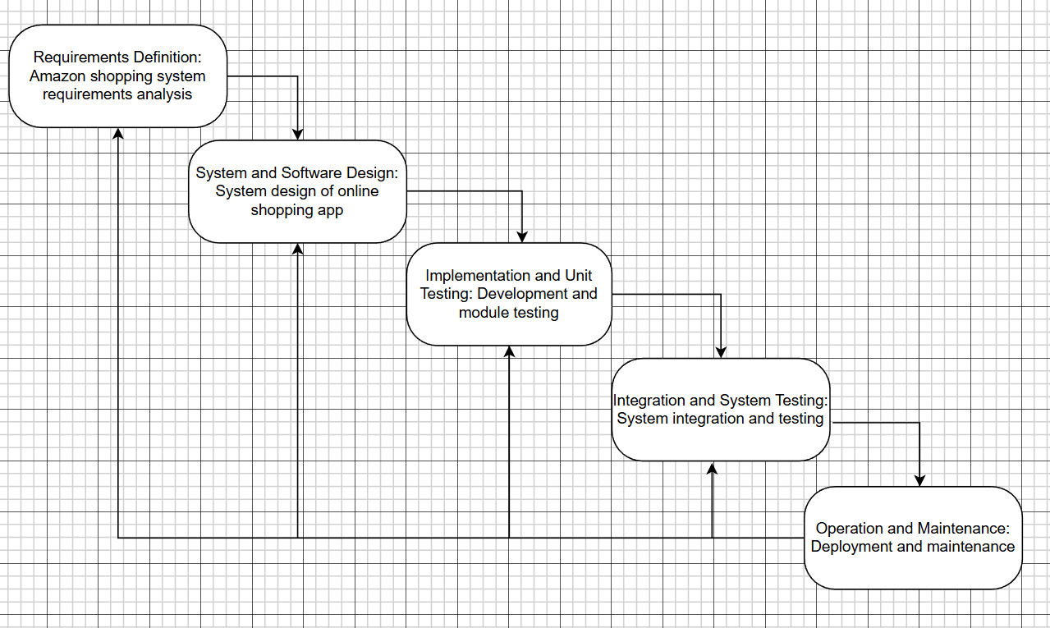

2. Incremental Model – Explanation for Amazon App
The Incremental model breaks down the system into small pieces where each increment goes through analysis, design, coding, and testing [2][3]. This plan will also work very well for Amazon. Instead of developing the entire app at once, the app will be divided into different parts. The first part can include user registration and viewing products, and the second part can include the shopping cart and order placement, and so on.

Each part will be done individually, starting with analysis, then design, implementation, and finally testing. Once each part of the app is done, it can be released, and then user feedback can be collected to improve the app. This plan will be very useful in case there are any changes to the requirements, like adding a new feature that allows users to have “same-day delivery [3]. This model enables early delivery of functional capabilities, improved user feedback, and step-by-step enhancement of non-functional requirements such as performance and usability. Therefore, it suits Amazon’s changing system.
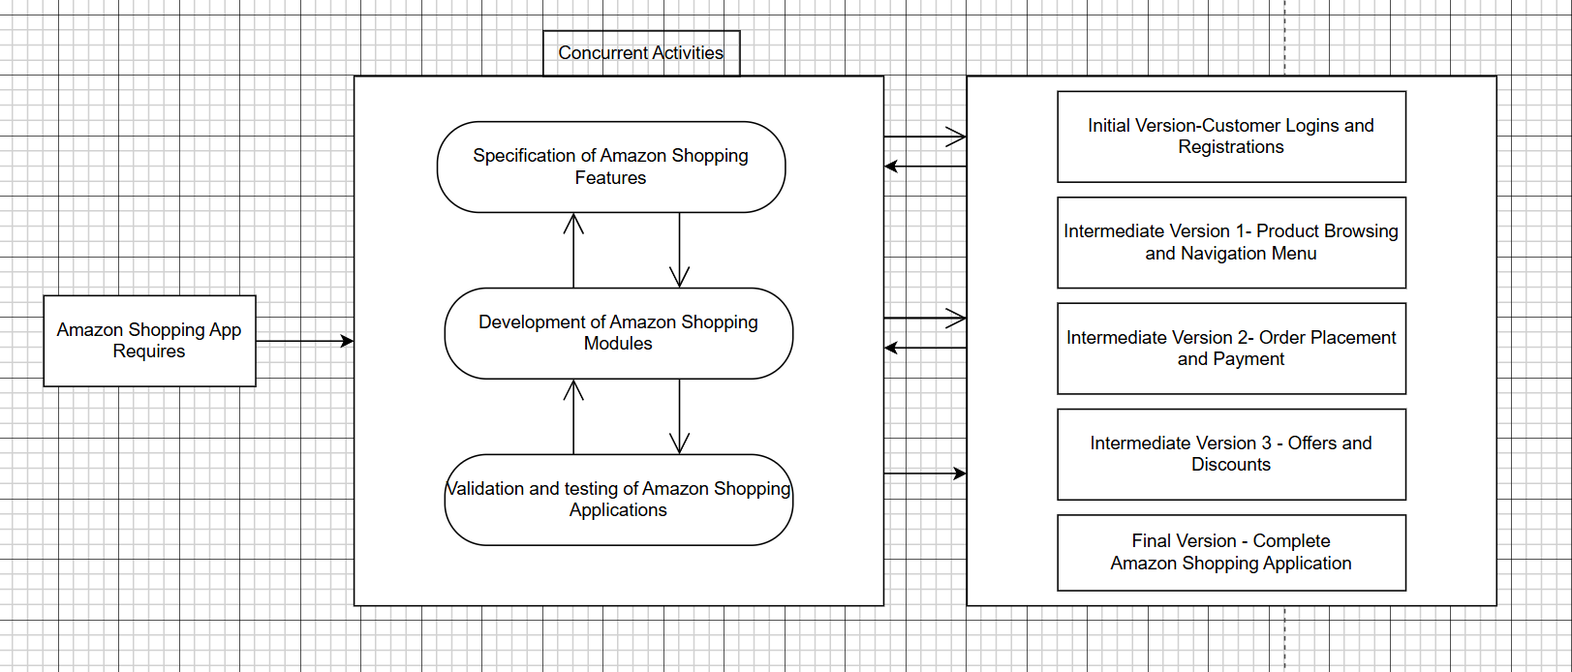

3. Spiral Model – Explanation for Amazon App
The Spiral model combines repetitive work and iterative deployment with thorough risk analysis [3][5]. Every cycle consists of four stages: planning, risk analysis, development, and review [5]. For Amazon, some risks might be security threats to payment, server overload during peak hours, data privacy issues, and integration issues.
During planning, objectives like implementing a new payment system are defined. During risk analysis, potential risks such as fraud or system failure are considered [5]. Then comes the development, testing, and receiving of user feedback, and then again comes the cycle with better requirements. The thing about managing data and a lot of traffic is that it is really important to manage the risks that come with it. The Spiral model is what helps manage these risks like the risks, the financial risks and the security risks of the Spiral model. I think the Spiral model is an strong model, for managing risks. The Spiral model requires a lot of time and a lot of money to use the Spiral model. The Spiral model is also a complex system to understand and work with the Spiral model.
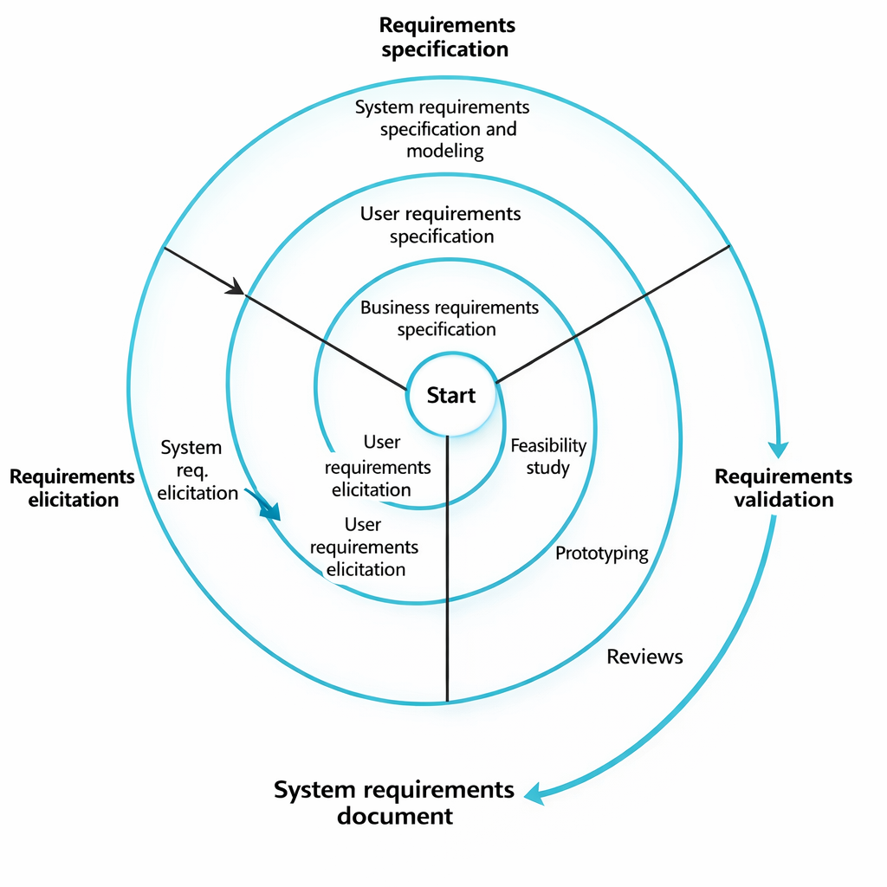

REQUIREMENT DOCUMENTS
Functional Requirements
- Registration and login of user
- Searching and viewing products
- Items are removed or added from cart
- Payments and checkout are done safely
- Tracking, cancelling, and returning orders
- Admin and seller management

Non-Functional Requirements
- Security should be strong
- Rapid performance
- Efficient and less downtime
- Handling many users
- Easy to use and maintain

Requirements Validation Strategy
In order to make sure all key features are clear and complete, the requirements are inspected by stakeholders. Users can confirm the system flow since simple prototypes may be used. Each requirement is verified to ensure it meets the business objectives, such as security and performance.
Test cases are created to check each requirement, and consistency checks are done to remove clashes and to make sure that the system is workable to build.
Challenges in Requirements Engineering
Requirement validation makes sure the system requirements are correct, complete, and constant [3]. The system keeps transforming so the requirements quiet oftenly change. Trying to understand the needs of many different users can also be difficult and hectic, leading to misunderstandings and complications. There may be conflicts between requirements, such as security versus performance. Managing requirements for such a large and complex system is itself a huge challenge.

COMPARISONS
Handling Functional Requirements
In this one, we have to decide single toy or game at the beginning. In online store like Amazon, it is very hard because they are always changing and adding new things. You have to add new things one by one to make easier to update. Checking in every step to make even better. So, the online store like Amazon always growing and changing.

Handling Non-Functional Requirements
It required to keep it safe from others. Security is needed. If performance should be to superfast, building is strong when... millions share up at once. It should be stronger locks. It is very difficult to change them. Store must be safer and faster. This helps us help the store to get be better within time flow.
Risk Management
The Waterfall approach does not care much about risk during the development phase. If there is a problem, it is usually discovered at the end. The Incremental approach reduces risk by testing each increment before proceeding. The Spiral approach is best at risk management since risk analysis is an integral part of every phase. This is very important for Amazon because even a small problem in the system can result in a huge loss.

Change Management
The Waterfall approach makes it very difficult to go back and change something after completing a phase. The Incremental approach is better in this regard because changes can be made between the increments. The Spiral approach is the most flexible because every phase allows changes to be made to the requirements. This is very important for an application like Amazon, which keeps changing all the time.

Time Constraints
The Waterfall approach takes longer because you do not get to see the final product until all phases are completed. The Incremental approach allows you to see the light at the end of the tunnel because it lets you see working versions of the product early on. The Spiral approach takes longer because of all the testing and analysis involved. However, this extra time results in a better system.

Cost Constraints
The Waterfall approach appears to be the cheapest at first because it does not require much spending initially. However, if changes are required, the cost skyrockets. The Incremental approach allows the cost to be spread over multiple phases. The Spiral approach is the most expensive because of all the risk analysis and iterations involved. However, the Spiral approach also reduces the risk of failure, which ultimately saves money in the long run.

LIMITATIONS AND FUTURE WORK
This is not the version of the text. It is not an application it is just something I am doing to learn how to make an application.. Even if we were making a real application and testing it on real users that would be good for making better applications and better tools. The application is what I am focusing on and the tools, for the application are what I want to improve. Making an application and testing the application on users of the application would be helpful.

RESULTS AND ANALYSIS
When you use an app, like Amazon you will see that there are ways to build it.. The thing is, these methods do not all work in the same way.
The waterfall model is one way it adds all the parts of the app at the time. So if you want to change something in the middle of building the app it is going to be more difficult to do that.
The incremental model and the spiral model are different they add parts of the app little by little. This is good because if you make a mistake it is easier to find the mistake and fix it.
The Amazon shopping app needs to be able to change it needs to run fast and it needs to be safe for people to use. The best model would be the step-by-step model.

CONCLUSION
In this case study, we learned how the Amazon shopping app can be developed using SDLC models like Waterfall, Incremental, and Spiral. To build a giant online store like Amazon using building blocks, there are three main ways to do. The waterfall way. In this, once you start, you have to complete fully. One cannot stop, go half away if you want different and fix it, and it is hard to fix. This is like an instruction book from first page to last. Incremental. This is like going step by step process, completing one section and moving on to other. Then you can see completing bit by bit. Spiral. This is like being careful, like you build a little and look back, see if there are any problems and fix them. Then move a little forward for big circle. In this, making sure nothing goes wrong.

REFERENCES
[1] NPTEL, “Software Engineering,” Online Course, IIT Kharagpur, Available: https://nptel.ac.in/courses/106105182
[2] Ian. Sommerville, Software Engineering, 10th ed., Pearson, 2016.
[3] R. S. Pressman and B. R. Maxim, Software Engineering: Practitioner’s Approach, 8th ed., McGraw-Hill Education, 2015.
[4] K. E. Wiegers and J. Beatty, Software Requirements, 3rd ed., Microsoft Press, 2013.
[5] B. Boehm, “A Spiral Model of Software Development and Enhancement,” Computer, IEEE

DECLARATION OF ACADEMIC INTEGRITY
I hereby declare that this assignment is my original work and has not been copied or plagiarized from any source. All references and resources used have been properly cited. Any ambiguities will lead to forfeiting my marks.


Signature:

Date :13-02-2026

